## Our Mission and Purpose

*The Commission for Ministry to Persons with Disabilities serves the Bishop and the Diocese of Kalamazoo by advocating for the needs of persons with disabilities, their families, and caregivers; assisting the Diocese and its parishes in inviting and facilitating the active participation of all parishioners in the life of faith, regardless of type, severity or age of onset of a disability; and strategizing, planning, and implementing programs and services that will comprise this ministry.*

As an advisory and working body to the Bishop, the Commission for Ministry to Persons with Disabilities exists to:

* Provide guidance, recommendations and resources for adaptation of programming for children and adults in religious education and youth ministry programs
* Conduct advocacy and educational awareness projects
* Plan and implement programs to serve the needs of persons with disabilities, their families and caregivers
* Pray, educate, affirm, counsel, advocate, and collaborate relating to issues pertinent to persons with disabilities
* Support diocesan and parish personnel who minister to persons with disabilities
* Discover and provide outreach to unserved and underserved persons.

**Catholic Charities Diocese of Kalamazoo**

1819 Gull Road

Kalamazoo, MI 49048

**Diocese of Kalamazoo**

215 N. Westnedge Ave.

Kalamazoo, MI 49007

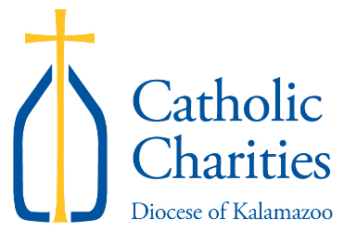

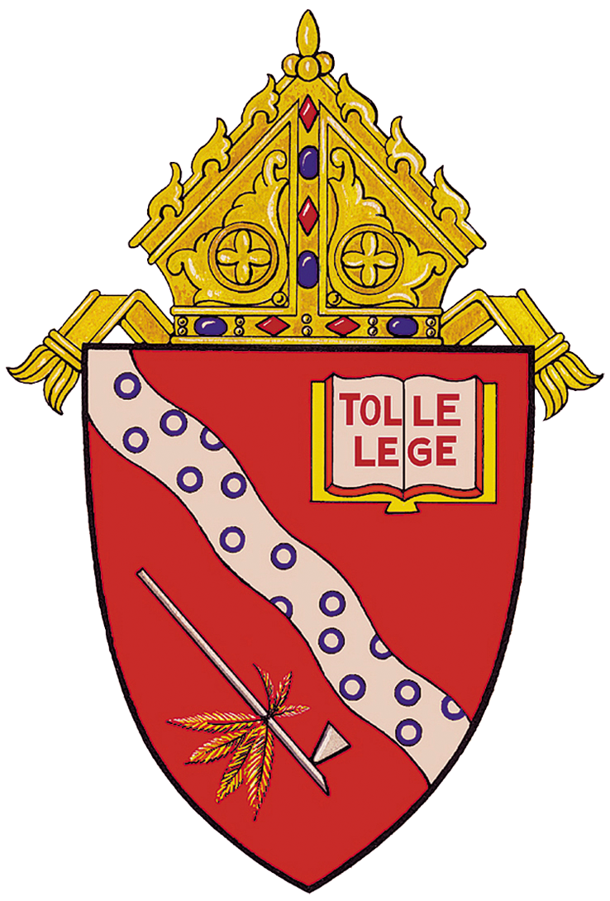

Diocesan Commission for Ministry to Persons with Disabilities

# Who can serve on the Commission?

The Commission supports the Sanctity

of the Human Person program at

Catholic Charities Diocese of

Kalamazoo. Annual events include:

* Advent Family Gathering for persons with disabilities and their families (all ages)
* Overnight Retreat for Adults with Cognitive/Developmental Disabilities
* Family Day Mass with Bishop Bradley and Picnic for persons with disabilities and their families (all ages)
* Day of Reflection for Adults with Cognitive/Developmental Disabilities

The Commission:

* Provides consultation for parishes
* Develops resources to assist parish staff and catechists in support of children and adults with disabilities
* Presents workshops at diocesan conferences
* Assists parishes in assessing their outreach to persons with disabilities.
* Facilitates Diocese of Kalamazoo Caregiver Connection, a monthly virtual gathering
* Facilitates Creative Connections, a bi-monthly virtual gathering for persons with disabilities

**For more information contact Lisa Irwin**

**at 269-381-9800 x227 or**

[**lisairwin@ccdok.org**](mailto:lisairwin@ccdok.org)

**Commission Members:**

Christine Rice, Chair

Debra Hess, Secretary

Marissa Ellinger

Anne Zemlick

**Ad Hoc Members:**

Diocesan Chaplain position open

Lisa Irwin, Program Director, Sanctity of the Human Person

Catholic Charities Diocese of Kalamazoo

Diocesan Liaison

## Events

**Members of the Commission are drawn from various backgrounds:**

* **Persons with disabilities**
* **Family members or caregivers of persons with disabilities**
* **Professionals with expertise in fields related to disabilities**
* **Parish professionals with responsibility for religious education of persons with disabilities**

**Commission membership should represent as much as possible the diversity and geographic expanse of the diocese.**

**Commission membership is limited to nine people. Members are appointed by the Bishop for three-year terms.**

# Resources

National Catholic Partnership on

Disabilities (NCPD)

<http://www.ncpd.org/>